Online Modules in Workday
The online modules can be found as follows:
- Copy and paste the following into your browser: http://one.jefferson.edu
- Login with your campus key and password sent in a separate email. For issues with your password, please contact the Help Desk at 215-955-7975.
- Go to the top of the page with the different apps. Click on the “Workday” app. 
- If you do not see this app, you may need to add it by clicking on “Add Apps & Tools.”

- Click on the Workday app (Self-Service for HR, Finance & Supply Chain) and save.
- Click on the “Menu” button at the top left of your page.
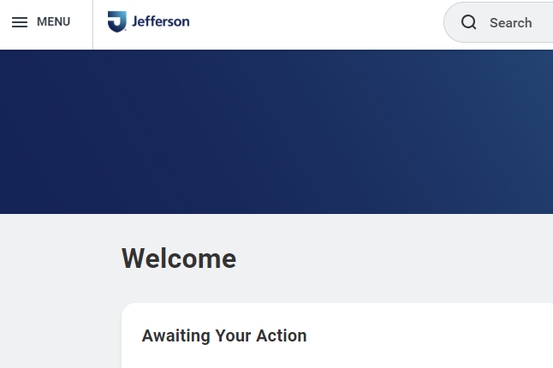

- Click on the “Learning” tab.

- Look at the “Required for You” assignments.
- You may see some assigned e-learnings. You will complete them next week during orientation. Do not start them until after orientation on Monday.

For any issues related to Workday or computer training,
contact the Help Desk at 215-955-7975.

We look forward to working with you!

